Содержание

How to go Virtual in BW Part I - The Open ODS View

Open ODS View in HANA EDW – The best of BW and HANA combined

Creating an ADSO from Open ODS view

OODS
- Можно преобразовать в ADSO.
- CV → OODS → BEx.
- Можно использовать в Composite Provider – только union.

How to go Virtual in BW Part I - The Open ODS View
https://www.just-bi.nl/virtual-bw-open-ods-view/

Содержание

The OODS & HCPR have been available since BW 7.40.
The difference between the two InfoProviders can be summed up as follows
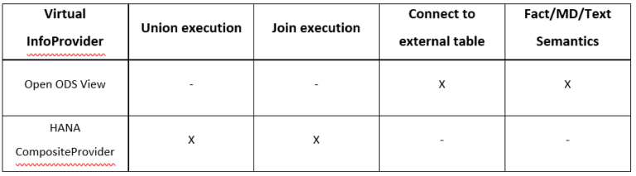

OODS View is abled to connect to external tables. Let’s say you have data sitting on an external database that you want to use in BW, however you don’t want to persist it. You can then set up a SDA -Smart Data Access Connection to that database and create a Virtual Table.

Open ODS view

External Table SDA connection Virtual table

Open ODS View Source Types

Open ODS View Source Types
- DataSource /BW/
- Database Table | View
- Virtual table using SAP HANA Smart Data Access
- ADSO
- Transformation

Source Type - DataSource (BW)

Rem

The OODS does not accept File-based DataSources.

Source Type - Database Table or View

It is the option you choose when you want to build an OODS View on a table residing in your local HANA database.
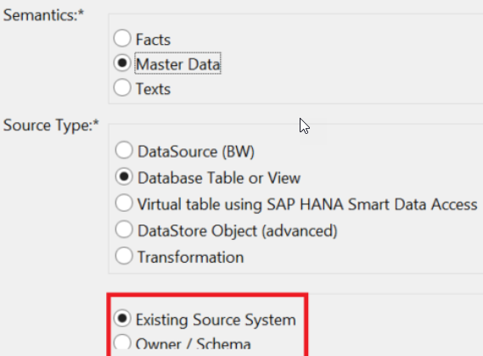

We are prompted by the screen to choose between Existing Source System and Owner / Schema.

Выбор Existing Source system

When you select Existing Source System - the system checks whether you have a HANA Source System [points towards a specific schema in your HANA Database].

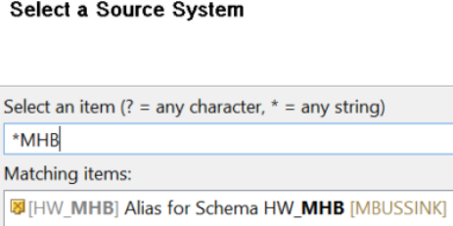

How to create a HANA Source System

First head to transaction RSA1 and go to Source Systems.
Then right-click your SAP HANA folder and select Create

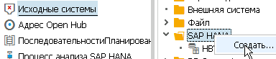.

Enter a Logical System Name which will be the technical name of your Source System. You could for instance give it the name of your schema - so you know with which schema it connects. Also you need to give your new Source System a description.

There are the different possible Connection Types
- If you have a local SAP HANA database schema - choose the first option 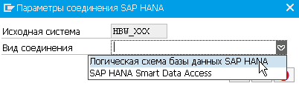.
- If you want to set up a Smart Data Access connection to an external table - choose the second. Because Database Table or View concern local HANA tables - we’re going to pick Local SAP HANA Database Schema.

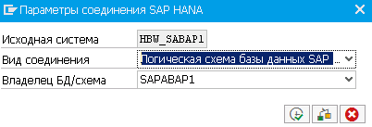

Now you can pick any table in the schema your Source System points to when creating an OODS View based on a database table or view

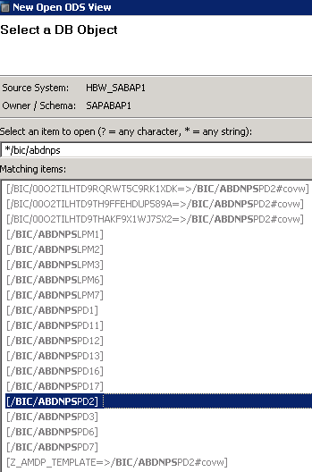

Выбор Owner / Schema - 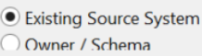

Whenever you select Owner / Schema on the first OODS creation screen the next screen will ask you to select a schema. After you’ve selected a schema, you need to choose the table you want.
After we press Next we can tell the difference between the Existing Source System and Owner / Schema options - you can either select an existing Source System or create a new one
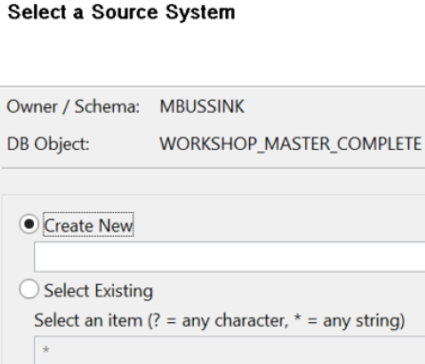.
Either way - you’re going to need a HANA Source System before you can start modeling your OODS ⇒ the Existing Source System and Owner / Schema options are basically 2 sides of the same coin.

Rem
The automatic Source System creation option does not always work - I got an error message
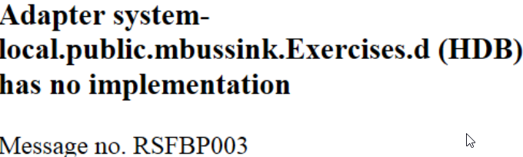.
If creating a Source System via the Owner/Schema option does not work - create one manually.

Privileges
After you create an OODS View based on a database table or view you might see the following error

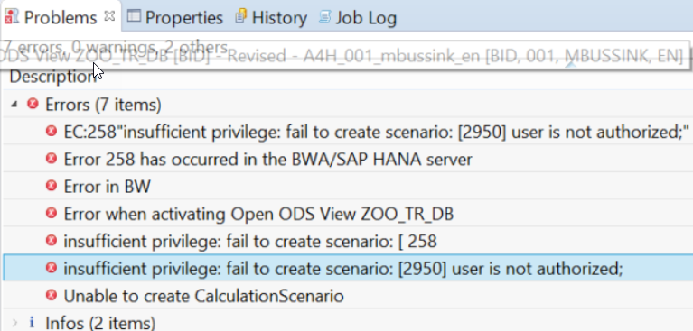

If you get this error - you need to grant your BW system user rights to whatever schema you want to build an OODS on. You do so by opening the SQL Editor in Eclipse and using the following statement

grant select on schema “MBUSSINK” to “SAPHANAABAP”

Source Type - Virtual table using SAP HANA Smart Data Access

This is the option you choose when you want to connect to an external table [such as a Hadoop table] without using a DataSource. Creating an OODS View using a virtual table is very similar to creating one based on a database table or view.

Pros & cons (ˌprəuən(d)'kɔn за и против)
Finally here’s an overview of the pros and cons of the OODS View
Open ODS View Criteria | + | - | Possible solutions for downsides
Time | Save time by modeling fields without InfoObjects. | InfoObjects ensure consistency and authorization functionality. | Associate fields with InfoObjects, when creating a long-term data model.
Space | Saves space because the OODS is a virtual object. | - | -
Performance | Query execution is pushed down to HANA database which benefits performance. | Dependent on external source for performance.  Performance penalty when interpreting fields without InfoObjects at runtime.  Complex transformations for large datasets perform badly at runtime. | Use Generate Dataflow option to persist OODS and/or associate fields with InfoObjects if performance is unsatisfactory.
Standardiza-tion | Can generate HANA SQL Views that can be consumed by 3rd party tools. | - | -
Flexibility | Can integrate external tables into BW. Don’t need InfoObjects to model fields.  Can change its structure/sources more easily than persistent InfoProvider.  Can designate ('dezɪgneɪt назначать) tables as Fact/MD/Text. | When using an SDA Source Type - you are dependent on external source to maintain the source table.  With field-based modeling and possible structural changes there is more freedom  but this flexibility can lead to a lack of consistency. | Persist external data with Generate Dataflow option - if external connection becomes unstable.  Associate fields with InfoObjects, when consistency is more necessary than shortterm flexibility.

Open ODS View in HANA EDW – The best of BW and HANA combined
https://blogs.sap.com/2014/10/17/open-ods-view-in-hana-edw-the-best-of-bw-and-hana-combined/

Содержание

SAP BW and SQL-minded approach termed HANA EDW /Enterprise Data Warehouse/.

The Open ODS field-based approach makes the following possible
- ODS Function modelling on remote data - HANA Smart Data Access.
- Integration of field data into EDW context – association of InfoObjects to OODS Views.
- BEx Queries atop OODS Views.
- Embed OODS Views into Composite Providers - only union is allowed for OODS Views up to SP7; join is supported as of SP8.

We will be demonstrating the technical capability of ODS Function modelling on remote data. In the NTT DATA landscape we have BW on HANA DB - namely H04 accessing a remote ECC on HANA DB -namely H03 which has the HANA Live Virtual Data Models installed. The landscape is illustrated below

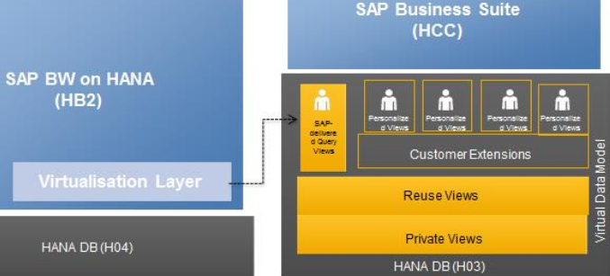

This landscape is represented in the HANA Studio as follows

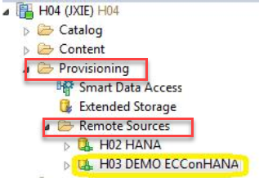

In HANA DB H03

In H03 we have created our own custom Calculation View Z_CC_PLAN_ACTUAL_TOTAL with a simple join of two HANA Live Reuse Views – CostCenterPlanActualCostTotals and ControllingArea

CV ntt.his.ecc.Z_CC_PLAN_ACTUAL_TOTAL H03 (JXIE)

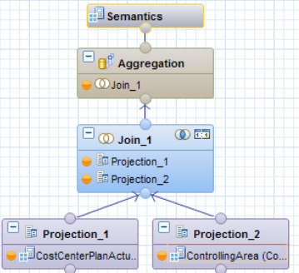

In the node Projection_1 we created a calculated column FiscalYearPeriod_E

string(string(“FiscalYear”) + lpad(string(“FiscalPeriod”), 3, ‘0’))

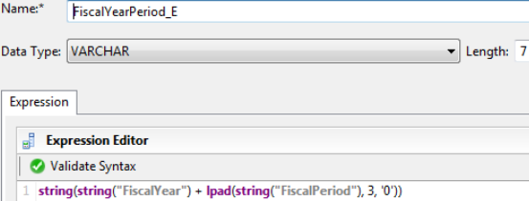

In BW HB2

In the next step let’s move to BW HB2 to create an OODS View which will allow us to consume/expose the HANA Calculation View Z_CC_PLAN_ACTUAL_TOTAL to BW.
Prior to the creation of an ODS View make sure a DB Connection is available

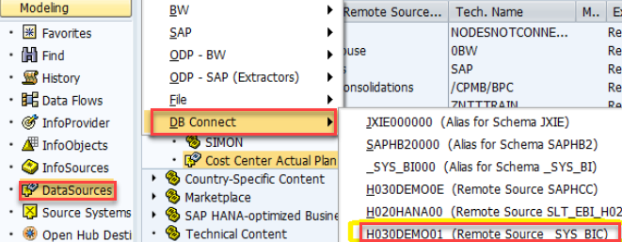

Then we have created an ODS View ZCOOM_OV01 with the type Virtual Table via HANA Smart Data Access based on our CV

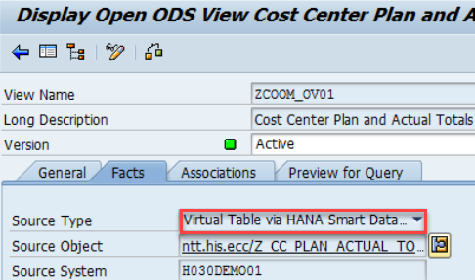

By using the Display Data functionality we see that the FiscalYearPeriod field is correctly populated via the calculated column in CV - in fact all the data available in the remote HANA system H03 is now available as an InfoProvider in BW

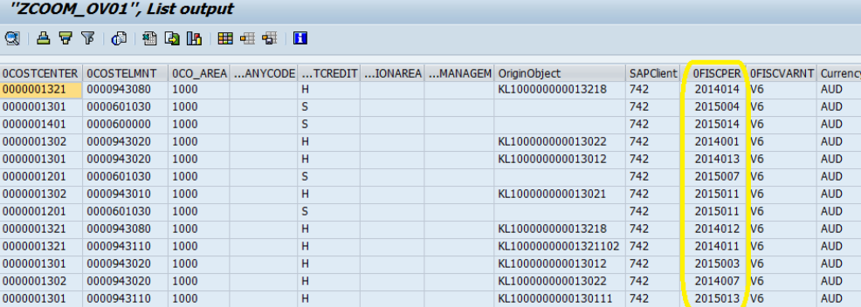

To integrate fields into an EDW context we have associated fields with InfoObjects. It’s also possible to associate fields with ODS Views and the purpose of InfoObjects association - is to leverage some of the features offered by BW Analytic Manager [aka OLAP Engine] - for example hierarchy support and Info Objects Navigational Attributes.
If a field is assigned to an InfoObject BW Analysis Authorisation can be leveraged as Authorisation relevancy of the InfoObject is inherited. Whereas if a field is not assigned to any InfoObject - BW also supports creating Analysis Authorisation directly based on the field. Below is an Analysis Authorisation created on the field CompanyCode

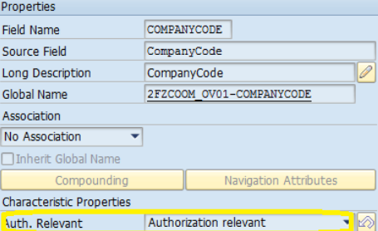

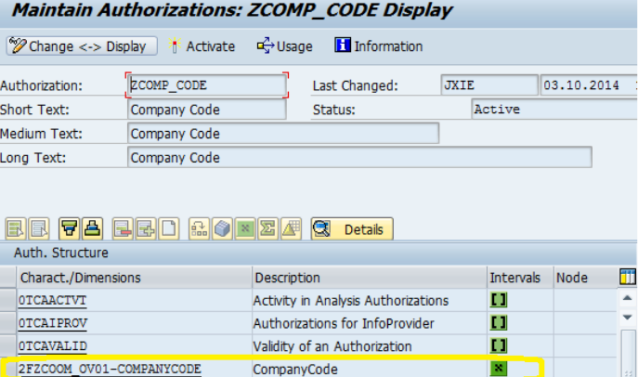

In the final step a BEx Query is created on top of the OODS View with the standard Cost Centre hierarchy enabled for display, which saves you from dealing with hierarchies within HANA. Please note that fields are also supported on BEx Query

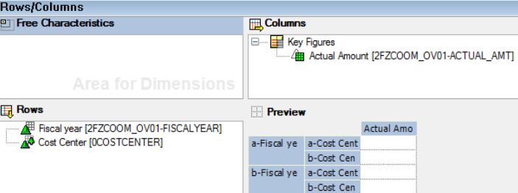

Where to from here?

Starting from SAP BW 7.4 you could embed ODS Views in a CompositeProvider. Unfortunately this allows you to do only UNION if you are not on SP8. Another limitation is that you can’t create an ODS View on most HANA Live Query Views due to their input parameters.

With BW 7.4 SP8 becoming generally available it provides the following features
- Use of ODS views as Source Objects and allowing JOINS to be used.
- Support of input parameters when ODS views are used as source objects.

Creating an ADSO from Open ODS view
https://blogs.sap.com/2014/12/04/creating-an-adso-from-open-ods-view/

Содержание

The ODS View - one of SAP BW 7.4 main enhancements and one of the strategic modeling objects for SAP BW on HANA in SAP simplification approach.
One of the key features of the OODS view - is developing BW objects without having actual data persistency in SAP BW.
From SAP BW 7.4 SP8 it’s now possible to actually generate an ADSO from existing ODS view inheriting all InfoObject assignments and field information. When used on an SAP ERP Datasource - it even creates a transformation to that Datasource and a Data Transfer Process.

An example

I created a basic generic extractor on table AUFK in SAP ECC and create a simple ODS View of type FACT without associations to other ODS Views or InfoObjects.

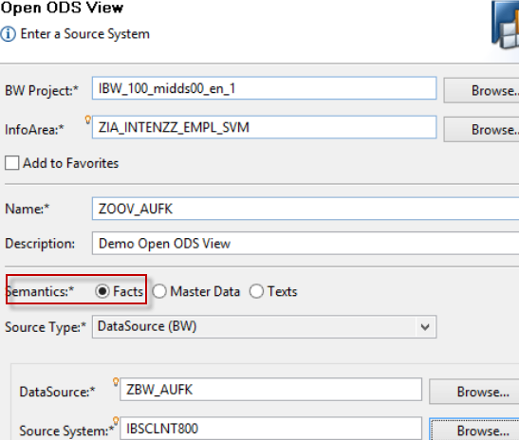

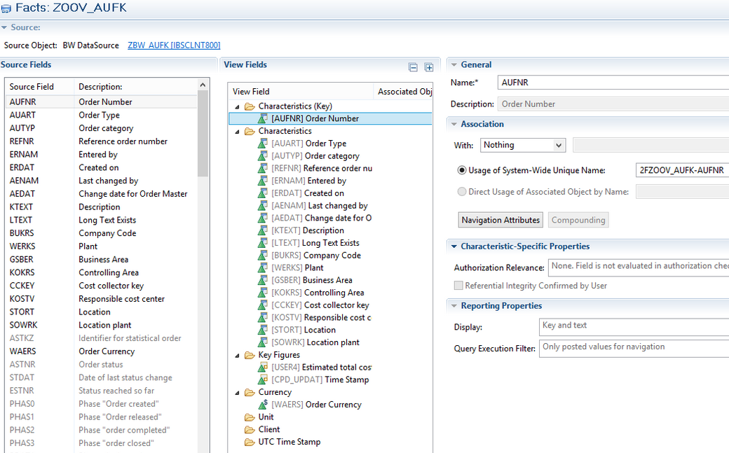

After checking and activating Data preview shows us about 6417 rows.
Then in the RSA1 we go into change mode for this ODS View and select the Generate Dataflow option. Clicking this button opens a dialog with settings for the dataflow generation

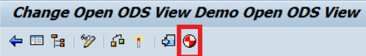

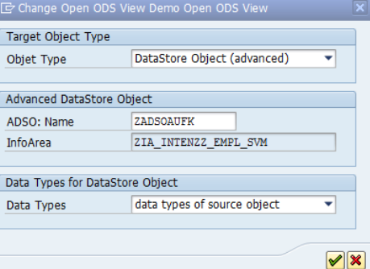

After successful completion of the process we now have an ADSO and corresponding data flow leading up to this ADSO [Infopackage has to be created manually].

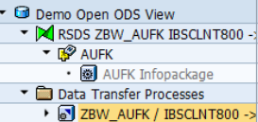

Loading and activating data shows us the same 6417 data records we had using the ODS View - but now persistent in BW. The data is exactly identical to the data we previewed with the ODS View earlier.

SAP HANA CDS-Views vs Calculation Views vs Table Functions
https://stackoverflow.com/questions/59682110/sap-hana-cds-views-vs-calculation-views-vs-table-functions

− What is now the difference between a table function which replaced scripted calculation views and CDS Views?

Calculation Views are to be prefered over Database-SQL-Views.

Somewhere around HANA 1 SPS11/12 most calculation views started to be unrolled /раскручиваться/ internally to feed /для подачи/ into the common optimizer - that was what /именно об этом/ the Execute in SQL Engine flag was about /говорил/.

calculation views common optimizer

SQL support and the underlying SQL optimizer were made more powerful - so much so that some SQL queries could be as fast/faster than those modeled in calculation views. Since then /с тех пор/ the performance argument for using calculation views only holds /имеет место/ in very specific circumstances.

SQL queries SQL optimizer [more powerful than common optimizer]

While SQL gives you the way to talk to the database; CDS wants to give your application a single data definition - that is used by the UI | the program logic | the data storage/query execution.
CDS advantage is that one can provide more inf. about the data model than what is possible in HANA SQL - associations and joins with cardinality declaration [albeit /хотя/ now retrofitted to plain SQL] can enable the optimizer to use additional optimizations.

The main point of CDS really is about application development process performance.

Now for the question scripted calc view vs. table function vs. CDS view

Looking at these different object types from the point of what can I do with them functionally? will result in the observation - basically the same. The difference lies in how these can be optimized - scripted calc views can’t be generally unrolled into the global query to be optimized.

Scripted Calc. view - can’t be generally unrolled into the global query to be optimized

Table functions SQL optimizer

Table functions allow for very easy reuse across multiple views and queries.
Functionally speaking table functions are a kind of swiss-army knife - one can do nearly anything with them and they still can be part of global query optimization.

The main reason why CDS views are a thing is that with HANA SAP started to develop development models [such as XS, XSA, CAM] that revolve /вращаются/ around virtual data models.

Calculation views certainly are an odd /странный/ development object. Training folks in using those and SQL most likely is overly expensive compared to just sticking to SQL ⇒ I prefer the code-based SQL development. The only thing SQL based development does not provide - is the extended annotations/semantic information used by the SAP analytic frontend tools [SAC & BO] - these really are specific to CDS and Information Models /calculation views/.

